Please contact us if you would like more information about the programs and services offered by SEDC’s International Language Bank.

**Phone:** 401.274.8811 x 14

**Fax:** 401.274.8877

**For 24/7 services, please call:** 401.419.3507

**Email:** MayKue.sedc@verizon.net

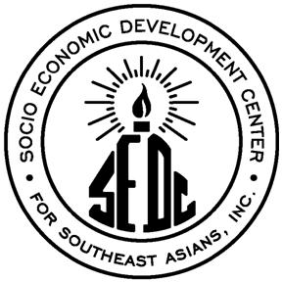

Socio-Economic Development Center for Southeast Asians (SEDC)

270 Elmwood Avenue

Providence, RI 02907

Tel: (401) 274-8811 Ext. 24

Fax: (401) 274-8877

<http://www.sedcsea.org>

**Why Choose the International Language Bank?**

The increase of non-English speaking people living in the U.S. means that the ability to communicate in other languages is becoming more important than ever. Multi-lingual skills are required to adequately provide services and market products to non-English speaking communities.

Without the best possible communication between the non-English speaking clients and a company employee, the service delivery process is compromised, cumbersome, costly, and ineffective.

Our commitment is to help you bridge the gap efficiently and effectively.

Do well while doing good:

All proceeds of the ILB benefit the Socio-Economic Development Center for Southeast Asians, a Providence-based nonprofit that promotes the evolution of healthy and productive citizens among people who have roots in Southeast Asia.

**International Language Bank**

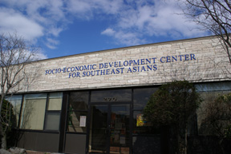

**More than 30 languages!**

**Services Include:**

**In-Person Interpreting**

**Document Translation**

**24/7 Emergency Services**

**Proceeds benefit:**

**The Socio-Economic Development Center**

***For Southeast Asians***

By choosing SEDC’s International Language Bank, you are able to receive high quality translation and interpretation services, while at the same time helping your community to grow and prosper

The money that SEDC earns through the Language Bank is returned to the community through SEDC’s social programs, such as:

· Youth and Family Development Program

· Family Support Program

· Victims of Crime Assistance

· Elderly Meal Site

· GED, ESL and Citizenship Classes

· Substance Abuse Prevention

SEDC is a 501 (3) c organization.

Contributions to SEDC are tax deductible to the fullest extent of the law.

***“Tom [my interpreter] is very professional. I will continue to use the Language Bank in the future. Very good services in court and with your staff.***

***—SEDC client***

We provide accurate, friendly, and confidential service. Our interpreters are always reliable and always professional.

Our clients include:

· Rhode Island Department of Children, Youth, and Families

· Rhode Island Department of Human Services

· Our Lady of Fatima Hospital

· Private lawyers

· District court

· Family Court

· Providence School Department

All proceeds from the International Language Bank benefit SEDC community programs.

**Our Services**

SEDC’s International Language Bank offers confidential and accurate interpretation, translation, and language services in **more** **than** **30 languages** at a competitive rate.

Our interpreters are experienced in translating and interpreting in the following areas:

· Legal

· Medical

· Technical

· Industrial

· Business

· Social Services

· Parent/School Communications

**Interpretation:**

Our interpreters are available by appointment to meet your needs. We commonly provide interpretation for hospitals, doctor’s offices, schools, and courts, and any organization that might request our services.

**Translations:**

We translate any materials such as consent forms, notices, instructions, employee handbooks, package inserts, advertisements, posters, brochures, pamphlets, etc.